Hood Canal Coordinating Council
Jefferson, Kitsap & Mason Counties;
Port Gamble S'Klallam & Skokomish Tribes

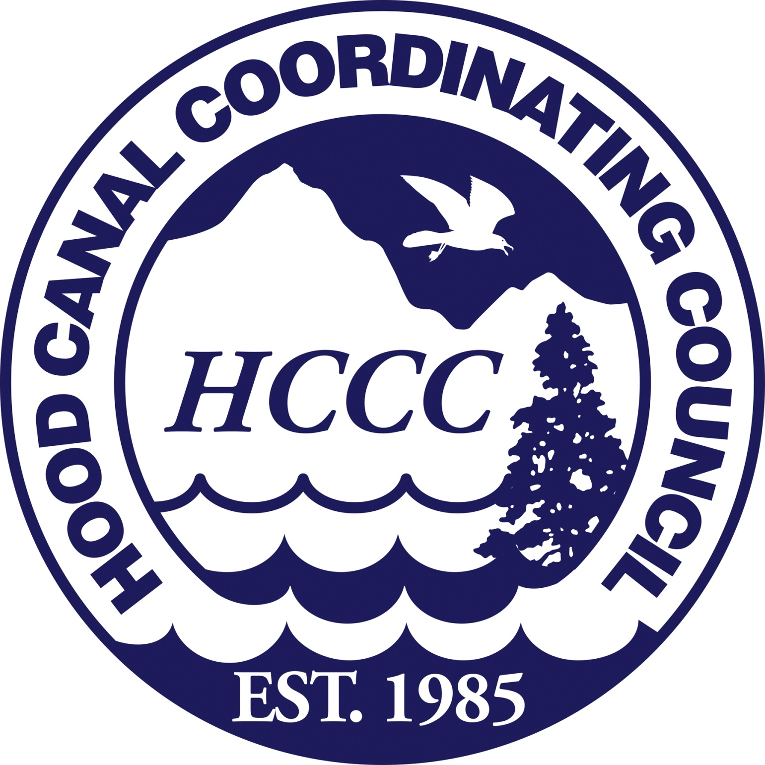

Regular Meeting of the Board of Directors – Draft Agenda
13 October 2015; 1:00 PM to 4:00 PM
Location: Oxford Suite, 9550 NW Silverdale Way, Silverdale WA

1:00 PM Call to Order, Introductions, Approval of Meeting Agenda
Randy Neatherlin, HCCC Chair

1:05 PM Public Comment (please limit time to approximately 2 min. per person)
Randy Neatherlin, HCCC Chair

1:10 PM Consent Items
All matters listed under Consent Items have been distributed to each member of the Board for reading and study, are considered to be routine, and will be enacted by one motion of the Board with no separate discussion. If a separate discussion is desired, that item may be removed from the Consent Items and placed as an additional topic by request.

- Approve Draft Board Meeting Summary 11 August 2015
- Approve Cash Disbursements and Expenditures
- Approve HCCC Hood Canal Environmental Achievement Award Winners as recommended by the Community Engagement Committee
- Approve Integrated Watershed Plan (IWP) Committee (includes four HCCC Board members--Dave Herrera, Paul McCollum, Phil Johnson and Terri Jeffreys) meetings schedule, topics, and location as follows:
- November 5, 1-4pm and November 20, 1-4pm
  - Purpose of committee meetings is to consider Local Integrating Organization (LIO) planning and prepare for Board review of Near Term Actions proposed for the Hood Canal LIO
  - Located at the HCCC office (Ste. 124) in Poulsbo

HCCC Board Outcome: Motion to approve consent items.

1:20 PM Washington Secretary of State Non-profit Corporation Annual Renewal
Robin Lawlis, HCCC Administrative Program Manager

HCCC Board Outcome: Motion to approve filing of the non-profit 501(c)(3) corporation annual renewal with the Secretary of State with a signature by the HCCC Board Secretary and Chair, Randy Neatherlin.

1:25 PM Hood Canal Watershed Education Network (HCWEN) Integration
Haley Harguth, HCCC Watershed Planning & Policy Coordinator

1. Present new LIO-Eco-Net Integration and propose regular HCWEN updates at HCCC Board of Directors meetings

HCCC Board Outcome: HCCC is informed of LIO-Eco-Net integration and supports adding a regular agenda item for HCWEN updates at future meetings.

1:40 PM Puget Sound Partnership Ecosystem Coordination Board Update
Teri King, Hood Canal Action Area Representative

- Update on current topics and proceedings of the Puget Sound Partnership Ecosystem Coordination Board pertinent to HCCC.
HCCC Board Outcome: HCCC Board is provided update.
1:50 PM HCCC Procurement Policies
Scott Brewer, HCCC Executive Director

- Discuss proposed HCCC Procurement policies

HCCC Board outcome: Board adopts the HCCC Procurement policies.

2:00 PM HCCC Lead Entity Remaining Funds
Randy Neatherlin, HCCC Chair
Alicia Olivas, HCCC Lead Entity Coordinator
HCCC Lead Entity Citizens Advisory Group

The HCCC Board Chair convenes the HCCC Lead Entity Citizens Committee (HCCC Board of Directors and HCCC Lead Entity Citizens Advisory Group).

- Update on 2015 Lead Entity Remaining Funding Options

HCCC Board outcome: HCCC Citizens Committee motion to obligate remaining 2015 SRFB and PSAR funds and returned 2013-2015 PSAR funds according to recommendations.

2:30 PM Local Integrating Organization (LIO) Update
Haley Harguth, HCCC Watershed Planning and Policy Coordinator

- Brief update on status of LIO Recovery Plan and Puget Sound Partnership Action Agenda planning process
- Update on HCCC Near Term Action (NTA) planning and timeline for upcoming Board decision

HCCC Board Outcome: HCCC Board is provided update.
3:00 PM In Lieu Fee (ILF) Mitigation Program
Patty Michak, HCCC Mitigation Program Manager

- Review of Myrvang Wetland acquisition and proposed purchase and sale agreement for the property.

HCCC Board Outcome: HCCC Board approves the purchase and sale agreement for the Myrvang Wetland acquisition.

3:15 PM Executive Session - In Lieu Fee (ILF) Mitigation Program
Patty Michak, HCCC Mitigation Program Manager

The purpose of the Executive Session is by reason of RCW 42.30.110(1)(b) to consider the selection of a site or the acquisition of real estate.

3:55 PM Public Comment and Hood Canal Happenings
Randy Neatherlin, HCCC Chair

4:00 PM Adjournment and Next Meeting
Randy Neatherlin, HCCC Chair

Next meeting: Annual Hood Canal Environmental Achievement Awards Celebration, Friday, November 6, 2015, 10:00 AM to 2:00 PM (R.S.V.P. to Robin; invitation will be sent separately) at the Lucky Dog Casino Events Center, 19330 N. U.S. Highway 101, Skokomish, Washington.
For more information about this meeting, contact Robin Lawlis, 360-394-0046 or rlawlis@hccc.wa.gov.

HCCC Board of Directors

David Herrera, Skokomish Tribe
David Sullivan, Jefferson County
Edward Wolfe, Kitsap County
Jeromy Sullivan, Port Gamble S’Klallam Tribe
Kathleen Kler, Jefferson County
Paul McCollum, Port Gamble S’Klallam Tribe
Phil Johnson, Jefferson County
Randy Neatherlin, Mason County
Rob Gelder, Kitsap County
Terri Jeffreys, Mason County

Exofficio Members
Partnership Ecosystem Coordination Board for Hood Canal
Puget Sound Partnership
US Navy Region Northwest
Washington State Dept. of Ecology
HCCC Staff

Alicia Olivas, Lead Entity Program Coordinator
Haley Harguth, Watershed Planning and Policy Coordinator
Heidi Huber, Programs Development Coordinator
Patty Michak, Mitigation Program Manager
Robin Lawlis, Administrative Program Manager
Scott Brewer, Executive Director
Tom Goishi, Accountant

The Hood Canal Coordinating Council is a Watershed-Based Council of Governments consisting of Jefferson, Kitsap and Mason Counties and the Port Gamble S’Klallam and Skokomish Tribes. It was established in 1985 in response to community concerns about water quality problems and related natural resource issues in the watershed.

Mission Statement: The Hood Canal Coordinating Council, working with partners, community groups and citizens, will advocate for and implement regionally and locally appropriate actions to protect and enhance Hood Canal’s environmental and economic health.

Board meetings schedule and documents can be found on the website at http://hccc.wa.gov/About+Us/Board+of+Directors Meeting Agendas

