Hood Canal Coordinating Council
Jefferson, Kitsap & Mason Counties;
Port Gamble S'Klallam & Skokomish Tribes

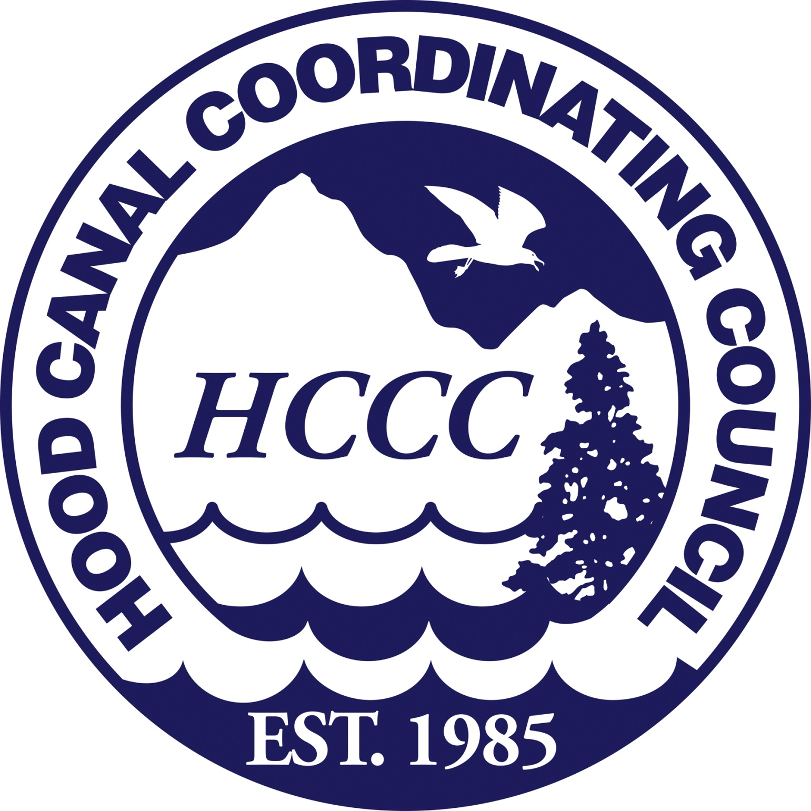

Regular Meeting of the Board of Directors – Draft Agenda
11 August 2015; 1:00 PM to 3:00 PM
Location: Oxford Suites, 9550 NW Silverdale Way, Silverdale, WA

1:00 PM Call to Order, Introductions, Approval of Meeting Agenda
Randy Neatherlin, HCCC Chair

1:05 PM Public Comment (please limit time to approximately 2 min. per person)
Randy Neatherlin, HCCC Chair

1:10 PM Consent Items
All matters listed under Consent Items have been distributed to each member of the Board for reading and study, are considered to be routine, and will be enacted by one motion of the Board with no separate discussion. If a separate discussion is desired, that item may be removed from the Consent Items and placed as an additional topic by request.

- Draft Board Meeting Summary
- Cash Disbursements
- Expenditures
- Revisions to HCCC Bylaws as approved at the 15 July 2015
  - Requires Board of Directors’ signatures at the meeting

HCCC Board Outcome: Motion to approve consent items.

1:20 PM Puget Sound Partnership Ecosystem Coordination Board Update
Teri King, Hood Canal Action Area Representative

- Update on current topics and proceedings of the Puget Sound Partnership Ecosystem Coordination Board pertinent to HCCC.
HCCC Board Outcome: HCCC Board is provided update.
1:30 PM 2015 HCCC Lead Entity Funding Round
Randy Neatherlin, HCCC Chair
Alicia Olivas, Lead Entity Coordinator
HCCC Lead Entity Citizens Advisory Group

The HCCC Board Chair convenes the HCCC Lead Entity Citizens Committee (HCCC Board of Directors and HCCC Lead Entity Citizens Advisory Group).

- 2015 HCCC Habitat Projects List Recommendations
HCCC Board Outcome: Citizens Committee approves and submits ranked 2015 HCCC Lead Entity Habitat Projects list to the Salmon Recovery Funding Board.
- 2015 HCCC Lead Entity Remaining Funding Options
HCCC Board Outcome: HCCC Citizens Committee motion to obligate remaining 2015 SRFB and PSAR funds and returned 2013-2015 PSAR funds according to recommendations.
- 2015 Intensively Monitored Watershed (IMW) Treatment Project
HCCC Board Outcome: HCCC Citizens Committee motion to submit HCCC IMW project proposals to Salmon Recovery Funding Board (SRFB) for statewide ranking and decision on IMW treatment funding.

2:00 PM HCCC Procurement Policies
Scott Brewer, HCCC Executive Director

- Discuss proposed HCCC Procurement policies

HCCC Board outcome: Board adopts the HCCC Procurement policies.

2:30 PM Executive Session - In Lieu Fee (ILF) Mitigation Program
Patty Michak, HCCC Mitigation Program Manager

The purpose of the Executive Session is by reason of RCW 42.30.110(1)(b) to consider the selection of a site or the acquisition of real estate.

2:55 PM Public Comment and Hood Canal Happenings
Randy Neatherlin, HCCC Chair

3:00 PM Adjournment and Next Meeting
Randy Neatherlin, HCCC Chair

Next meeting: Regular Meeting of the Board of Directors, Tuesday, September 8, Mason Transit-Community Center, 601 W Franklin Street, Shelton, WA (Parking for the facility is street parking around the area).
For more information about this meeting, contact Robin Lawlis, 360-394-0046 or rlawlis@hccc.wa.gov.

HCCC Board of Directors

David Herrera, Skokomish Tribe
David Sullivan, Jefferson County
Edward Wolfe, Kitsap County
Jeromy Sullivan, Port Gamble S’Klallam Tribe
Kathleen Kler, Jefferson County
Paul McCollum, Port Gamble S’Klallam Tribe
Phil Johnson, Jefferson County
Randy Neatherlin, Mason County
Rob Gelder, Kitsap County
Terri Jeffreys, Mason County

Exofficio Members
Partnership Ecosystem Coordination Board for Hood Canal
Puget Sound Partnership
US Navy Region Northwest
Washington State Dept. of Ecology
HCCC Staff

Alicia Olivas, Lead Entity Program Coordinator
Haley Harguth, Watershed Planning and Policy Coordinator
Heidi Huber, Programs Development Coordinator
Patty Michak, Mitigation Program Manager
Robin Lawlis, Administrative Program Manager
Scott Brewer, Executive Director
Tom Goishi, Accountant

The Hood Canal Coordinating Council is a Watershed-Based Council of Governments consisting of Jefferson, Kitsap and Mason Counties and the Port Gamble S’Klallam and Skokomish Tribes. It was established in 1985 in response to community concerns about water quality problems and related natural resource issues in the watershed.

Mission Statement: The Hood Canal Coordinating Council, working with partners, community groups and citizens, will advocate for and implement regionally and locally appropriate actions to protect and enhance Hood Canal’s environmental and economic health.

Board meetings schedule and documents can be found on the website at http://hccc.wa.gov/About+Us/Board+of+Directors+and+Meeting+Agendas/default.aspx

