Hood Canal Coordinating Council
Jefferson, Kitsap & Mason Counties;
Port Gamble S'Klallam & Skokomish Tribes

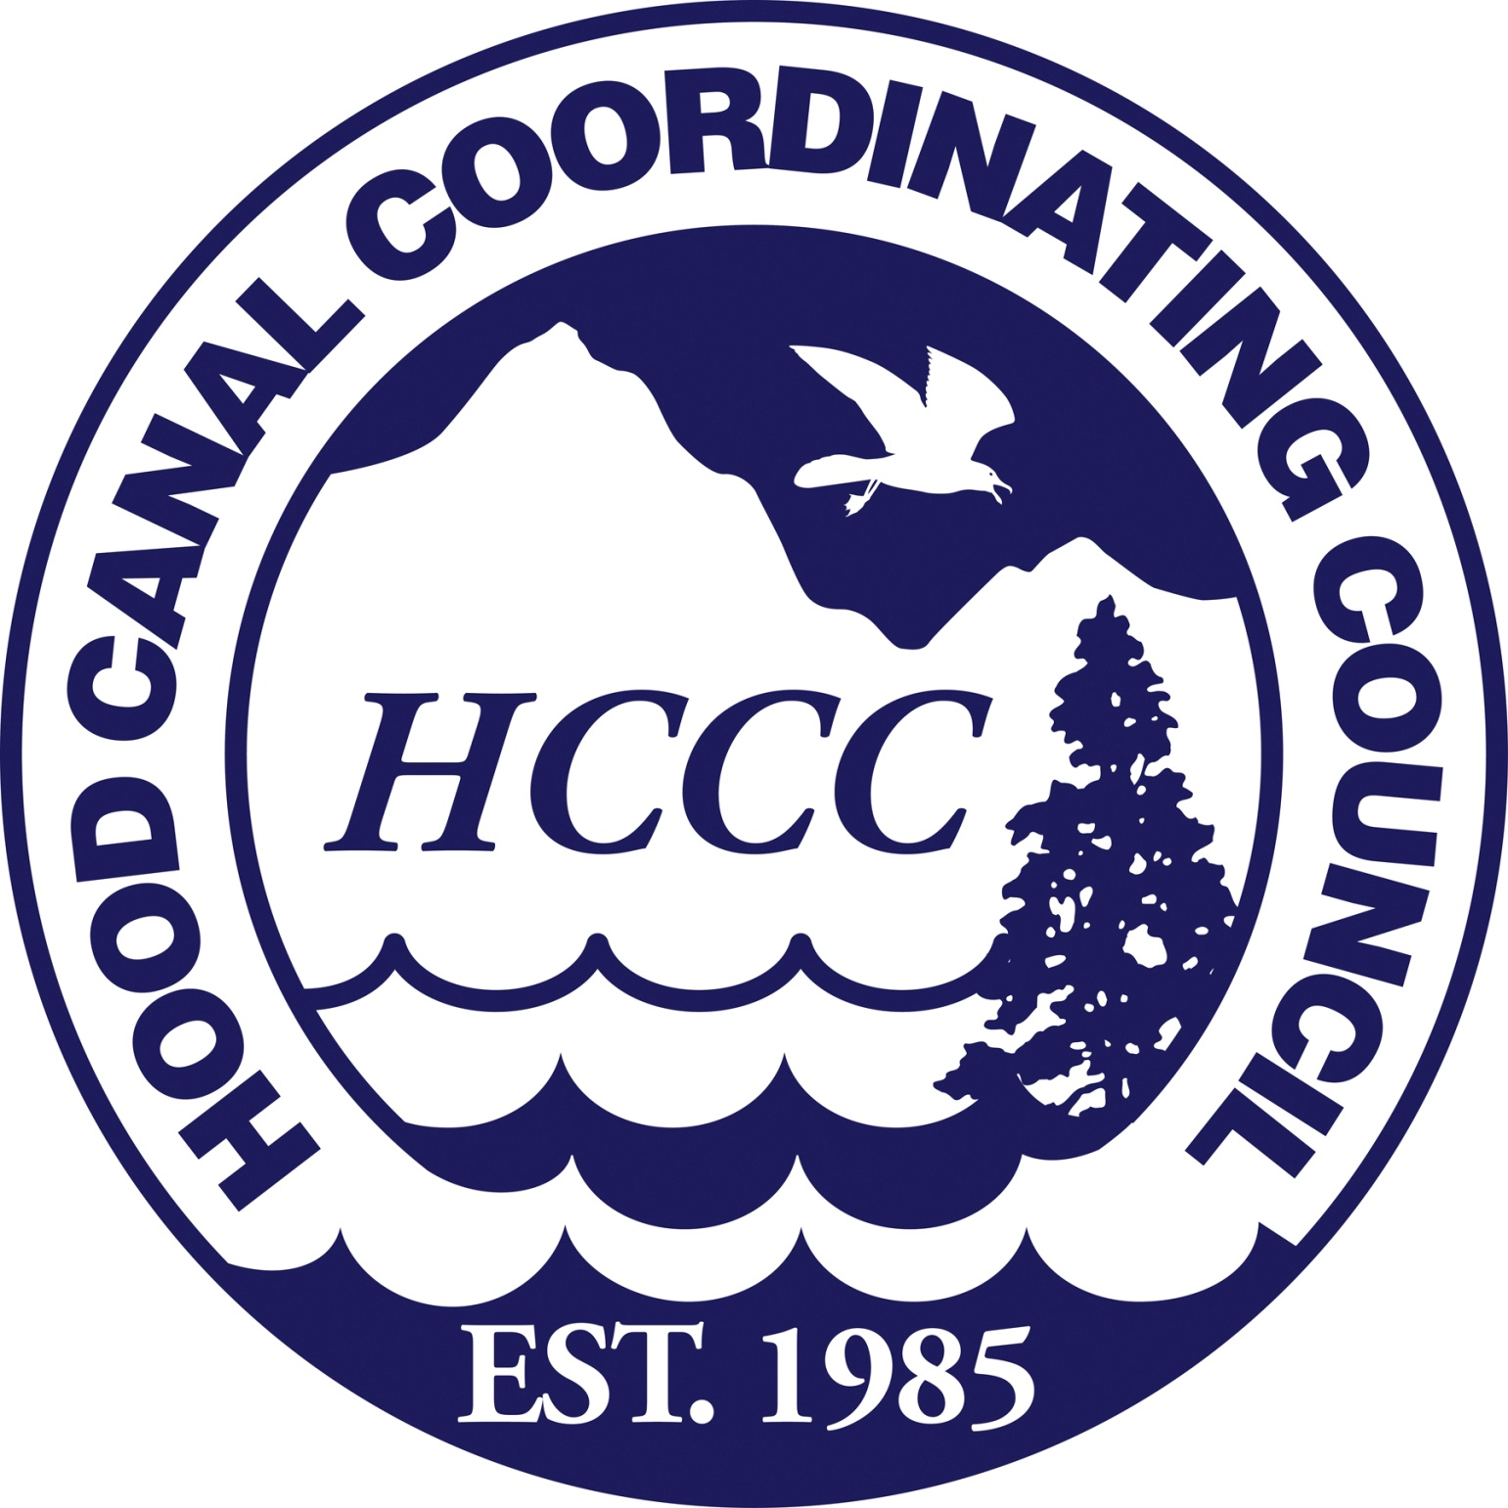

Regular Meeting of the Board of Directors – Draft Agenda
15 July 2015; 1:00 PM to 4:00 PM
Location: Oxford Suites, 9550 NW Silverdale Way, Silverdale, WA

1:00 PM Call to Order, Introductions, Approval of Meeting Agenda
Randy Neatherlin, HCCC Chair

1:05 PM Public Comment (please limit time to approximately 2 min. per person)
Randy Neatherlin, HCCC Chair

1:10 PM Luke Cherney Appreciation Celebration
Randy Neatherlin, HCCC Chair

Recognize Luke Cherney for his years of dedicated service to the Hood Canal Coordinating Council.

1:15 PM Consent Items
All matters listed under Consent Items have been distributed to each member of the Board for reading and study, are considered to be routine, and will be enacted by one motion of the Board with no separate discussion. If a separate discussion is desired, that item may be removed from the Consent Items and placed as an additional topic by request.

- Draft Board Meeting Summary
- Cash Disbursements
- Expenditures

HCCC Board Outcome: Motion to approve consent items.

1:20 PM 2015 Lead Entity Process
Alicia Olivas, Lead Entity Coordinator
HCCC Lead Entity Citizens Advisory Group

The HCCC Lead Entity Citizens Committee (HCCC Board of Directors and HCCC Lead Entity Citizens Advisory Group) convenes to engage in discussion and guidance around the 2015 Lead Entity Process to date.

- Citizens Advisory Group (CAG) Introductions
- Review Lead Entity Proposal Evaluation Process and Funding Update
- CAG Presents Recommendations of 2015 Grant Round Project List for Preliminary Review
- Citizens Committee Discussion

HCCC Board Outcome: Board meets with Citizens Advisory Group as the full Citizens Committee and discusses the Lead Entity project list to be submitted to the Salmon Recovery Funding Board (SRFB) for the SRFB funding decision. HCCC Board and Citizen’s Committee provides guidance on next steps.

2:00 PM HCCC Bylaws Revision
Scott Brewer, HCCC Executive Director

- Revise language Article IV, Section 11 to reflect new non-profit requirements:

  - COMMITTEES. - The Board of Directors may establish such committees as necessary to further the purposes of the Council. Committees shall be chaired by a member of the Board of Directors, and shall include at least one other member of the Board of Directors. Committees may include citizens, public agencies with relevant expertise, and affected groups.

HCCC Board outcome: Motion to approve revisions to HCCC Bylaws and signs revised By-Laws

2:15 PM HCCC Draft Procurement Procedures
Scott Brewer, HCCC Executive Director

- Review and discussion of the Procurement Procedures and Construction Purchasing Procedures.

HCCC Board outcome: Board to provide guidance to HCCC staff regarding next steps in addressing the HCCC procurement procedures and construction purchasing procedures

2:40 PM Executive Director Report
Scott Brewer, Executive Director

Update on current topics pertinent to HCCC.

2:55 PM Executive Session - In Lieu Fee (ILF) Mitigation Program
Patty Michak, HCCC Mitigation Program Manager

The purpose of the Executive Session is by reason of RCW 42.30.110(1)(b) to consider the selection of a site or the acquisition of real estate [discussion held in separate room].

3:55 PM Public Comment and Hood Canal Happenings
Randy Neatherlin, HCCC Chair

4:00 PM Adjournment and Next Meeting
Randy Neatherlin, HCCC Chair.

Next meeting: Regular Meeting of the Board of Directors, Tuesday, August 11, Oxford Suites, 9550 NW Silverdale Way, Silverdale, WA.

HCCC Board of Directors

David Herrera, Skokomish Tribe
David Sullivan, Jefferson County
Edward Wolfe, Kitsap County
Jeromy Sullivan, Port Gamble S’Klallam Tribe
Kathleen Kler, Jefferson County
Paul McCollum, Port Gamble S’Klallam Tribe
Phil Johnson, Jefferson County
Randy Neatherlin, Mason County
Rob Gelder, Kitsap County
Terri Jeffreys, Mason County

Exofficio Members
Partnership Ecosystem Coordination Board for Hood Canal
Puget Sound Partnership
US Navy Region Northwest
Washington State Dept. of Ecology
HCCC Staff

Alicia Olivas, Lead Entity Program Coordinator
Haley Harguth, Watershed Planning and Policy Coordinator
Heidi Huber, Programs Development Coordinator
Luke Cherney, Salmon Biologist/GIS Coordinator
Patty Michak, Mitigation Program Manager
Robin Lawlis, Administrative Program Manager
Scott Brewer, Executive Director
Tom Goishi, Accountant

The Hood Canal Coordinating Council is a Watershed-Based Council of Governments consisting of Jefferson, Kitsap and Mason Counties and the Port Gamble S’Klallam and Skokomish Tribes. It was established in 1985 in response to community concerns about water quality problems and related natural resource issues in the watershed.

Mission Statement: The Hood Canal Coordinating Council, working with partners, community groups and citizens, will advocate for and implement regionally and locally appropriate actions to protect and enhance Hood Canal’s environmental and economic health.

Board meetings schedule and documents can be found on the website at http://hccc.wa.gov/About+Us/Board+of+Directors+and+Meeting+Agendas/default.aspx

